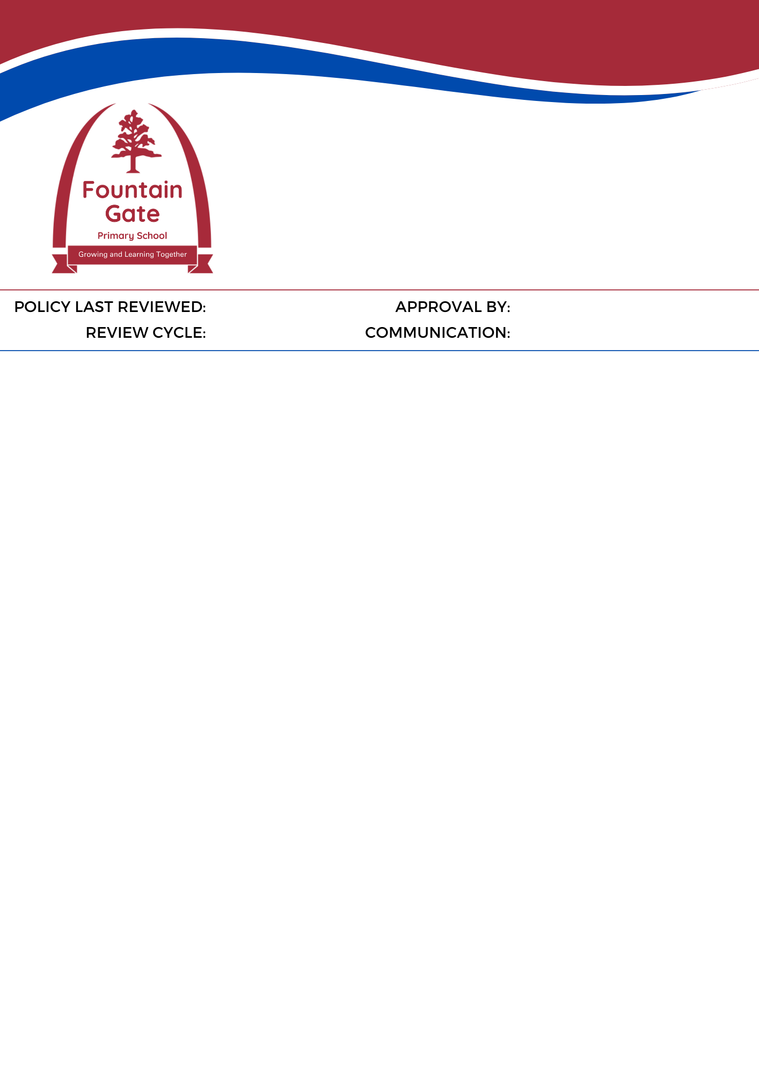

Parent Payments Policy

 | POLICY LAST REVIEWED | March 2025 | APPROVAL BY | Principal with School Council consultation
 | REVIEW CYCLE | 1 year | COMMUNICATION | School Website

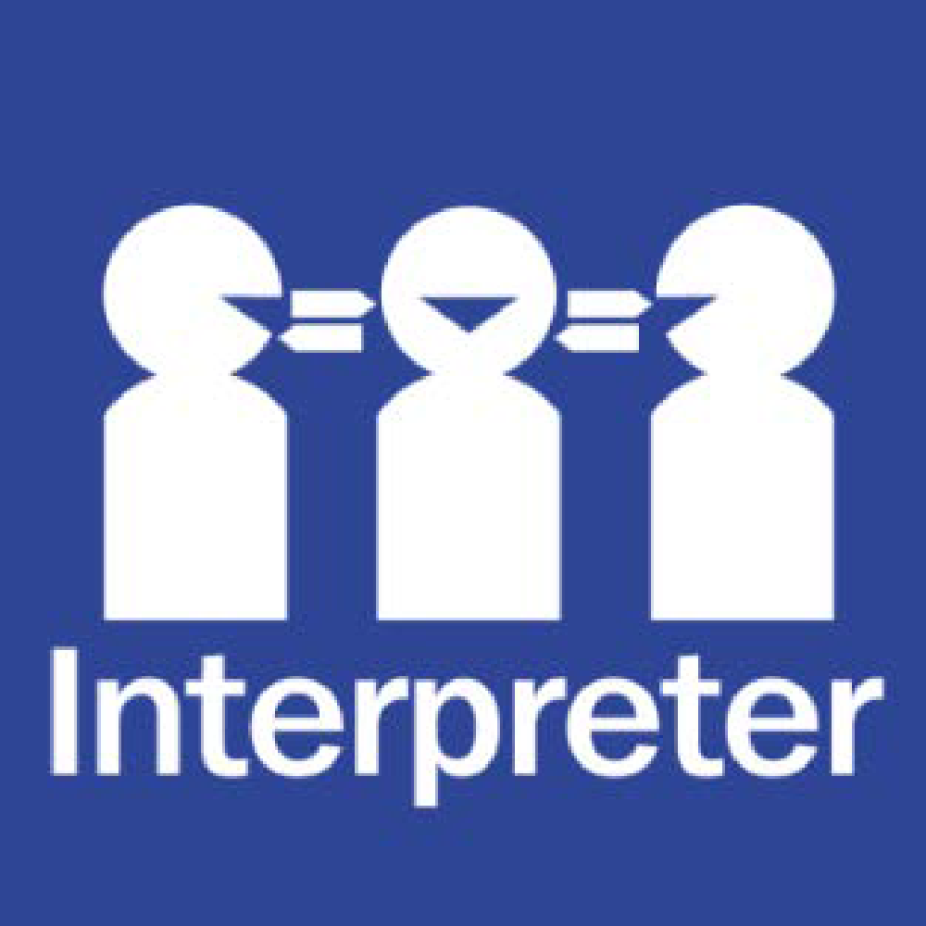
Help for non-English speakers
If you need help to understand the information in this policy please contact the school on 9703 1187

Under the Department of Education and Training’s Parent Payments Policy, Victorian government schools are required to provide transparent information to their school community on voluntary parent/carer contributions.
The following document outlines the voluntary parent/carer contributions at our school: 2025 Voluntary Parent Contributions.

